Pepperoni analyses

Philip Dixon

2024-11-11

## The first 6 rows of the data

pepperoni <- read.csv('pepperoni.csv')  
pepperoni <- pepperoni %>%  
 mutate(  
 trt.f = factor(trt)  
 )  
  
head(pepperoni)

## trt dose heat hardness loghard trt.f  
## 1 a 0 usual 12.15 2.50 a  
## 2 a 0 usual 13.88 2.63 a  
## 3 a 0 usual 7.25 1.98 a  
## 4 a 0 usual 15.26 2.73 a  
## 5 a 0 usual 18.56 2.92 a  
## 6 a 0 usual 15.08 2.71 a

## Summaries of each group

pepperoni %>%  
 group_by(trt) %>%  
 summarize(  
 n = n(),  
 average = mean(hardness),  
 sd = sd(hardness)  
 )

## # A tibble: 4 × 4  
## trt n average sd  
## <chr> <int> <dbl> <dbl>  
## 1 a 8 14.1 3.89  
## 2 b 8 12.5 4.86  
## 3 c 8 18.3 7.11  
## 4 d 8 22.9 12.7

## Analysis of untransformed observations

pepperoni.lm <- lm(hardness ~ trt.f, data=pepperoni)  
anova(pepperoni.lm)

## Analysis of Variance Table  
##   
## Response: hardness  
## Df Sum Sq Mean Sq F value Pr(>F)   
## trt.f 3 518.04 172.679 2.7507 0.06135 .  
## Residuals 28 1757.71 62.775   
## ---  
## Signif. codes: 0 '***' 0.001 '**' 0.01 '*' 0.05 '.' 0.1 ' ' 1

plot(predict(pepperoni.lm), resid(pepperoni.lm), pch=19)

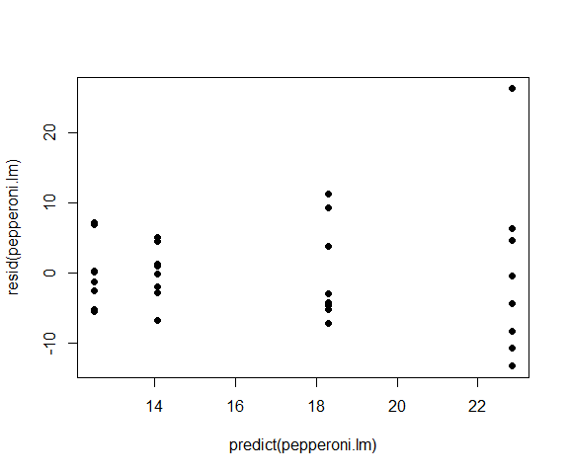

pepperoni.emm <- emmeans(pepperoni.lm, 'trt.f')  
summary(pepperoni.emm, infer=c(T,T))

## trt.f emmean SE df lower.CL upper.CL t.ratio p.value  
## a 14.1 2.8 28 8.33 19.8 5.021 <.0001  
## b 12.5 2.8 28 6.77 18.2 4.465 0.0001  
## c 18.3 2.8 28 12.57 24.0 6.536 <.0001  
## d 22.9 2.8 28 17.12 28.6 8.158 <.0001  
##   
## Confidence level used: 0.95

contrast(pepperoni.emm, list(  
 c1 = c(1, -1, 0, 0),  
 c2 = c(1, 0, 0, -1),  
 c3 = c(0, 0, 1, -1)  
 ), infer=c(T,T) )

## contrast estimate SE df lower.CL upper.CL t.ratio p.value  
## c1 1.55 3.96 28 -6.56 9.670 0.393 0.6976  
## c2 -8.79 3.96 28 -16.90 -0.675 -2.219 0.0348  
## c3 -4.54 3.96 28 -12.66 3.570 -1.147 0.2610  
##   
## Confidence level used: 0.95

## Analysis of log transformed observations

pepperoni.lm <- lm(loghard ~ trt.f, data=pepperoni)  
anova(pepperoni.lm)

## Analysis of Variance Table  
##   
## Response: loghard  
## Df Sum Sq Mean Sq F value Pr(>F)   
## trt.f 3 1.4212 0.47372 2.8488 0.05537 .  
## Residuals 28 4.6561 0.16629   
## ---  
## Signif. codes: 0 '***' 0.001 '**' 0.01 '*' 0.05 '.' 0.1 ' ' 1

plot(predict(pepperoni.lm), resid(pepperoni.lm), pch=19)

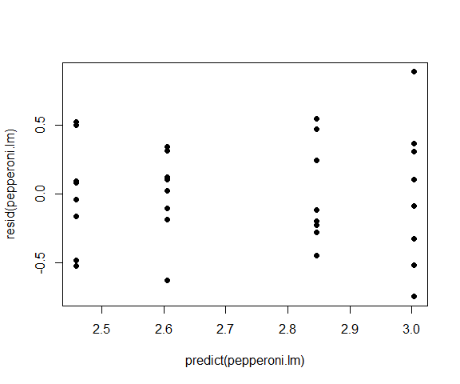

pepperoni.emm <- emmeans(pepperoni.lm, 'trt.f')  
summary(pepperoni.emm, infer=c(T,T))

## trt.f emmean SE df lower.CL upper.CL t.ratio p.value  
## a 2.60 0.144 28 2.31 2.90 18.069 <.0001  
## b 2.46 0.144 28 2.16 2.75 17.054 <.0001  
## c 2.85 0.144 28 2.55 3.14 19.742 <.0001  
## d 3.00 0.144 28 2.71 3.30 20.834 <.0001  
##   
## Confidence level used: 0.95

contrast(pepperoni.emm, list(  
 c1 = c(1, -1, 0, 0),  
 c2 = c(1, 0, 0, -1),  
 c3 = c(0, 0, 1, -1)  
 ), infer=c(T,T) )

## contrast estimate SE df lower.CL upper.CL t.ratio p.value  
## c1 0.146 0.204 28 -0.271 0.5639 0.717 0.4791  
## c2 -0.399 0.204 28 -0.816 0.0189 -1.956 0.0605  
## c3 -0.158 0.204 28 -0.575 0.2602 -0.772 0.4463  
##   
## Confidence level used: 0.95